Association of Hemispheric Laterality with Neurosurgery in ICH: A Post-Hoc Bayesian Analysis of ATACH-2 and ERICH

Authors: Nikhil M Patel, MD, MBA¹ ²; Rahul R Karamchandani, MD²; Matthew N Jaffa, DO; Liang Wang, PhD⁴; Hongmei Yang, PhD⁴; Rhonda Cadena, MD¹; Christa Swisher, MD²; Joe D Bernard, MD⁵; Jonathan M Parish, MD⁵; William R Stetler, MD⁵; Rick Magun, MD⁶; Aaron Taylor, MD⁶; Daniel Woo, MD⁶; Adnan Qureshi, MD⁷; Andrew W Asimos, MD⁸; Nicholas A Morris, MD⁹

Affiliations:
¹ Department of Internal Medicine, Wake Forest School of Medicine, Advocate Health, Charlotte, NC, USA.
² Department of Neurology, Neurosciences Institute, Wake Forest School of Medicine, Advocate Health, Charlotte, NC, USA.
³ Division of Neurocritical Care, Department of Neurology, Ayer Neuroscience Institute, Hartford Hospital, Hartford, CT, USA.
⁴ Clinical Quality Analytics, Advocate Health, Charlotte, NC 28203, USA.
⁵ Carolina Neurosurgery & Spine Associates, Department of Neurosurgery, Neurosciences Institute, Wake Forest University School of Medicine, Advocate Health, Charlotte, NC, USA.
⁶ Department of Neurology, University at Buffalo Jacobs School of Medicine & Biomedical Sciences, Buffalo, NY, USA.
⁷ Zeenat Qureshi Stroke Institute and Department of Neurology, University of Missouri-Columbia, Columbia, MO, USA.
⁸ Department of Emergency Medicine, Neurosciences Institute, Advocate Health, Charlotte, NC, USA.
⁹ Department of Neurology, Program in Trauma, University of Maryland School of Medicine, Baltimore, MD, USA.

Corresponding Author:
Nikhil M Patel, MD, MBA
Department of Internal Medicine
Department of Neurology
Wake Forest School of Medicine
1000 Blythe Blvd.
Charlotte, NC 28203
nikhil.m.patel@wfusm.edu

Word Count (excluding title, abstract, acknowledgment, references, tables, and figure legends): 1559

Author contributions:
Nikhil Patel had full access to all the data in the study and takes responsibility for the integrity of the data and the accuracy of the data analysis.
Concept and design: Patel, Jaffa, Karamchandani, Morris
Acquisition, analysis, or interpretation of data: Patel, Wang, Yang, Woo, Qureshi
Drafting of manuscript: Patel, Jaffa, Karamchandani
Critical review of the manuscript for important intellectual content: Patel, Karamchandani, Jaffa, Cadena, Swisher, Bernard, Parish, Stetler, Magun, Taylor, Woo, Qureshi, Asimos, Morris
Statistical analysis: Patel, Wang, Yang
Supervision: Woo, Qureshi, Asimos, Morris

Abstract
Background: Hemispheric laterality influences clinical management in stroke. Given the increasing enthusiasm for surgical management of intracerebral hemorrhage (ICH), we evaluated the association of hemispheric lateralization with the likelihood of receiving neurosurgical intervention and subsequent 90-day functional outcomes.
Methods: This post-hoc analysis included 3477 patients with supratentorial ICH from the ATACH-2 and ERICH studies. The primary outcome was neurosurgical intervention (hematoma evacuation, decompressive craniectomy, or other craniotomy). Secondary outcomes included external ventricular drain (EVD) placement, 90-day modified Rankin Scale (mRS), and EuroQOL domains. Hierarchical Bayesian regression models were adjusted for age, admission Glasgow Coma Scale, ICH location, ICH volume, and intraventricular hemorrhage.
Results: Of 3477 patients, right hemispheric ICH was associated with a higher likelihood of receiving neurosurgical intervention (aOR 1.65, 95% CrI 1.28–2.14) and EVD placement (aOR 1.22, 95% CrI 1.04–1.44) compared to left hemispheric ICH. This association was directionally consistent across ICH locations, study cohorts, and prior specifications. Despite the lower rates of aggressive surgical management, patients with left hemispheric ICH demonstrated similar 90-day functional outcomes, exhibiting equivalent mRS scores and potentially better outcomes in specific health-related quality of life domains.
Conclusions: Right hemispheric ICH is associated with a higher likelihood of neurosurgical intervention compared to left hemispheric ICH, though 90-day functional outcomes remain similar between groups. While these findings highlight a potential laterality-driven disparity in treatment paradigms, residual confounding from unmeasured anatomical severity and family preferences cannot be excluded. Prospective studies are needed to delineate the explicit clinical and prognostic drivers of surgical decision-making to optimize treatment allocation in ICH.

Trial Registration: Clinicaltrials.gov Identifier: ATACH-2, NCT01176565; ERICH, NCT01202864

Introduction
Intracerebral hemorrhage (ICH) remains a challenging disease, marked by its sudden onset, morbidity, and mortality.^{1,2} While management of ischemic stroke has advanced considerably over the last decade, the acute management of ICH remains limited to blood pressure control, coagulopathy reversal, and perhaps surgical evacuation of hemorrhage.^{3,4} These efforts have focused on reducing mortality and preventing additional morbidity due to secondary injury.
Clinical presentations for patients with stroke are varied based on the hemisphere affected, where hemispheric dominance dictates cognitive processing, attention, language, and emotional responses. Consequently, when confronted with ICH, the specific hemisphere affected can profoundly influence not only the clinical presentation but also management decisions and prognostic outcomes.
Previous research involving patients with ischemic stroke provide evidence that those with right hemispheric injury present later to the hospital and may not be treated as frequently with thrombolytic therapy.^{5–8} Some practitioners hesitate to offer decompressive craniectomy in patients with left dominant-hemispheric ischemic infarcts despite literature demonstrating that long-term functional outcomes and health-related quality of life (HRQoL) are equivalent if not better for patients with left hemispheric injuries.^{9–12}
Amidst an increasing enthusiasm for surgical management of ICH^{3,4,13}, it is important to understand if hemispheric lateralization is associated with differences in surgical decision making, as has been observed for ischemic stroke. We aimed to evaluate the association of hemispheric lateralization of ICH with the likelihood of receiving neurosurgical intervention as well as with functional outcomes.

Methods

Study Design and Participants
We conducted a post-hoc analysis using data from two prospective studies: the Antihypertensive Treatment of Acute Cerebral Hemorrhage II (ATACH-2) trial and the Ethnic/Racial Variations of Intracerebral Hemorrhage (ERICH) study. ATACH-2 was a large, multicenter, international, open-label, blinded-endpoint randomized controlled trial that enrolled 1000 patients with ICH from 2011 to 2016 and randomized them to either intensive blood pressure control (110-139 mm Hg) or standard blood pressure control (140-179 mm Hg). ERICH was a large, multicenter, prospective observational study that enrolled patients in the United States admitted with ICH from 2010 to 2017, with particular emphasis on recruitment of a racially and ethnically diverse cohort. The protocols and results of both studies have been previously published elsewhere.^{14,15}
We included all patients enrolled in these two studies with supratentorial location of ICH. We excluded patients with cerebellar or brainstem ICH as well as any patient with primary intraventricular hemorrhage (IVH).
The study was approved by the institutional review board of the Wake Forest School of Medicine (IRB00098198).

Exposures and Outcomes
Our exposure was hemispheric laterality (left versus right). Our primary outcome was neurosurgical intervention as a binary variable defined as receiving a hematoma evacuation, decompressive craniectomy, or other craniotomy.
To explore differences in other aspects of aggressive care, we defined several secondary outcomes: receipt of external ventricular drain (EVD), receipt of tracheostomy, days of mechanical ventilation, receipt of do-not-resuscitate (DNR) order at any point in the hospitalization, withdrawal of life-sustaining therapy (WLST) at any point in the hospitalization, and early WLST (defined as < 72 from symptom onset).
Our primary functional outcome was modified Rankin score (mRS) at 90 days analyzed via ordinal regression. We also examined quality of life as assessed by the European Quality of Life-5 dimensions (EQ-5D) questionnaire.

Statistical Analysis
Associations between hemispheric laterality and clinical outcomes were evaluated using hierarchical Bayesian regression models, adjusting for the covariates listed below with a random intercept applied to the enrolling study cohort.
We employed Bayesian statistical methods for this analysis due to several advantages over traditional frequentist approaches. Bayesian methods allow for the incorporation of prior knowledge or beliefs into the analysis, which can be particularly useful in observational studies where prior information about relationships between variables may exist. This is achieved through the use of prior distributions, which are combined with the observed data to produce posterior distributions representing updated beliefs about the parameters of interest. Furthermore, Bayesian methods provide a natural framework for quantifying uncertainty through credible intervals (CrI), which offer a more intuitive interpretation than frequentist confidence intervals. Finally, Bayesian modeling facilitates the estimation of posterior probabilities, allowing for direct probabilistic statements about hypotheses, such as the probability that an effect size (e.g., odds ratio [OR] or incidence rate ratio [IRR]) is greater than 1, which is often of greater clinical relevance than a p-value.^{16,17} This report adheres to the Bayesian Analysis Reporting Guidelines.¹⁸
Binary, ordinal, and count-based outcomes were modeled using hierarchical Bayesian logistic, ordinal logistic, and zero-inflated negative binomial regressions, respectively. The European Quality of Life Visual Analog Scale (EQ-VAS) was scaled to a proportion and analyzed via hierarchical Bayesian zero-one inflated beta (ZOIB) regression. Because our adjusted models included an interaction term between hemispheric laterality and ICH location, the raw main-effect coefficients for laterality are conditional on the reference location. To calculate the overall average effect of laterality across the entire cohort, we applied marginal standardization (G-computation) to all models. This allowed us to estimate average marginal effects by averaging over the empirical distribution of all covariates and the random intercept.
To account for potential clustering of clinical decision-making by hospital, we ideally would have included a random intercept for the study site in all models. However, site-level identifiers were not available for the ERICH cohort. To assess the potential impact of omitting site-level clustering, we performed a sensitivity analysis restricted to the ATACH-2 cohort, where site identifiers were available. We fitted the primary model for neurosurgical intervention with and without a random intercept for hospital site and compared the posterior estimates for the association with laterality.
All analyses were performed in R version 4.4.2 (R Foundation for Statistical Computing, Vienna, Austria). All packages used for the analysis are listed in the Supplementary Appendix.

Covariate Selection
We constructed directed acyclic graphs (DAGs) to model our causal assumptions and to guide covariate selection for each estimand.^{19–21} For neurosurgical intervention and other acute care outcomes, the target estimand was the total effect of hemispheric laterality on treatment decisions. Models were adjusted for baseline confounders that influence both the clinical presentation associated with hemispheric laterality and the likelihood of intervention: age, admission Glasgow Coma Scale (GCS) score, ICH location (categorized as lobar, thalamic, or basal ganglia), baseline ICH volume, and presence of intraventricular hemorrhage (IVH).
For functional outcomes (mRS and EQ-5D), the target estimand was the total effect of hemispheric laterality, encompassing all causal pathways including those mediated through neurosurgical intervention and other post-baseline care decisions. These models were adjusted for the same baseline confounders but did not condition on neurosurgical intervention, as it lies on the causal pathway from laterality to functional outcome; adjusting for a mediator would block the clinically relevant pathway and risk introducing collider stratification bias.²⁰ The DAGs and further details of the covariate selection rationale are presented in the Supplementary Appendix.

Prior Distribution Specification
To assess the robustness of our findings, we applied four sets of prior distributions for the primary exposure across all models. Because the models utilize different link functions depending on the outcome distribution (e.g., logit for binary/ordinal outcomes, log for count outcomes), these priors correspond to log-odds ratios (OR), log-incidence rate ratios (IRR), or log-mean differences.
The four prior sets were: (1) a neutral, weakly informative prior centered on a null effect (Normal(0, 0.5)); (2) an informative left-hemisphere prior favoring outcomes in left-hemispheric patients (Normal(-0.22, 0.175)); (3) an informative right-hemisphere prior favoring outcomes in right-hemispheric patients (Normal(0.18, 0.175)); and (4) a vague, diffuse prior (Normal(0, 5)) that provides minimal information to the posterior, approximating the assumptions of a frequentist analysis. Further rationale and empirical evaluations of these priors are detailed in the Supplementary Appendix.

Computation and Description of the Posterior Distribution
For the effect of hemispheric laterality, we report the following metrics derived from the marginalized posterior distributions: 1) the median posterior effect size with 95% credible intervals (CrI); 2) the probability of any directional difference; 3) the probability of a substantial difference defined a priori; and 4) the percentage of the posterior distribution falling outside a predefined region of practical equivalence (ROPE).
Effect sizes are reported as marginal odds ratios (OR) for binary and ordinal models, marginal incidence rate ratios (IRR) for the count component of the negative binomial models, and average marginal expected mean differences on the original 0–100 scale for the EQ-VAS (derived via G-computation). We defined a substantial difference as an odds ratio (OR) > 1.2 (or a mean difference of 5 points for the Euro VAS). In the context of invasive procedures such as hemicraniectomy or hematoma evacuation, we posited that a 20% relative shift in treatment odds represents a threshold that would meaningfully impact clinical and shared decision-making. The full rationale for these thresholds and the ROPE bounds for ORs and IRRs are detailed in the Supplementary Appendix.

Missing Data Treatment and Sensitivity Analyses
Baseline covariates used in model adjustment (e.g., age, GCS, ICH volume) had minimal missingness (< 1%). Missingness for 90-day functional outcomes was more substantial but was balanced across laterality groups. Detailed missingness rates, assessments supporting the Missing at Random (MAR) assumption, and imputation diagnostics are reported in the Supplementary Appendix.
Our primary analysis used multiple imputation by chained equations (MICE) to address missing data, generating 20 imputed datasets using the mice package. Imputation models included all analysis covariates and all primary and secondary outcomes. Including all functional outcomes (e.g., mRS and EuroQOL domains) in the imputation equations allowed them to serve as highly informative auxiliary variables for one another, optimizing the imputation of missing outcome data. Predictive mean matching was used for continuous and ordinal variables, logistic regression for binary variables, and polytomous regression for nominal variables. Each Bayesian model was fitted separately to each imputed dataset, and posterior draws were pooled across imputations to produce the reported estimates and CrI. A complete-case sensitivity analysis was also performed.

In addition to the missing data analysis, we analyzed our models using the four sets of prior distributions described above. To evaluate potential effect modification on acute care decisions, we fitted models containing formal interaction terms between hemispheric laterality and ICH location, and laterality and study source. Because missingness in baseline covariates and acute surgical outcomes was negligible, these exploratory subgroup interaction models—as well as a prespecified sensitivity analysis for all outcomes—were fitted to complete-case data (excluding patients missing the specific outcome being modeled) for computational efficiency. Subgroup-specific aORs and interaction Ratio of Odds Ratios (ROR) with 95% CrI were computed to evaluate heterogeneity.

Data Availability Statement
The ATACH-2 (PI: Adnan I. Qureshi, MD, NCT01176565) and ERICH (PI: Daniel Woo, MD, MS, NCT01202864) data and analyses presented in this manuscript are based on the research files downloaded from the Archived Clinical Research web site of the National Institute of Neurologic Disease and Stroke (NINDS). The datasets can be obtained after approval of a written proposal as outlined on the NINDS website. As outlined in the NINDS Data Request Agreement, the analysis code is publicly available at https://github.com/nikhilpatelmd/ich-laterality.

Results

Baseline Characteristics
A total of 3477 patients were included in the analysis, of which 1720 (49%) had left hemispheric ICH (Table 1). They had higher National Institutes of Health Stroke Scale (NIHSS) scores, lower GCS scores, and lower rates of hypertension as compared to those with right hemispheric ICH. There were 2487 (72%) patients in the cohort from ERICH and 990 (28%) from ATACH-2.

Hemispheric Laterality and Neurosurgical Intervention
Associations between hemispheric laterality and primary and secondary outcomes are shown in Table 2. 86 (5.0%) patients with left hemispheric ICH underwent neurosurgical intervention, compared to 144 (8.2%) with right hemispheric ICH (aOR 1.65, 95% CrI 1.28–2.14). The posterior probability that the aOR exceeded 1 was > 99.9%, and the posterior probability of a substantial difference (aOR > 1.2) was 99.3%. Fewer than < 0.1% of the posterior distribution fell within the ROPE.
In exploratory subgroup analyses, the association between right hemispheric ICH and neurosurgical intervention remained directionally consistent across all evaluated ICH locations and source studies. Formal interaction analyses yielded wide credible intervals for the Ratio of Odds Ratios (ROR), providing insufficient evidence to conclude that the laterality effect differed meaningfully across these subgroups (Supplemental Table 10).
Figure 1 displays the covariate-adjusted marginal predicted probabilities of neurosurgical intervention and the prior sensitivity analysis. Panel A shows the posterior distributions of covariate-adjusted absolute predicted probabilities of neurosurgical intervention for left and right hemispheric ICH under the neutral prior (left hemisphere: 4.86%, 95% CrI 3.98–5.84%; right hemisphere: 8.04%, 95% CrI 6.93–9.23%). Panel B shows the posterior distributions of the absolute probability difference (Right − Left) across all four prior specifications. Under the neutral prior, the median probability difference was 3.18 percentage points (95% CrI 1.75–4.62), with P(Right > Left) exceeding 99.9%. Corresponding estimates were 2.21 percentage points (95% CrI 0.97–3.45) under the left-hemisphere prior, 2.84 percentage points (95% CrI 1.60–4.09) under the right-hemisphere prior, and 3.38 percentage points (95% CrI 1.90–4.89) under the diffuse prior, with P(Right > Left) exceeding 99.9% under all specifications. Further details are available in Supplemental Tables 14-17.
In a sensitivity analysis restricted to the ATACH-2 cohort, a random intercept for the enrolling hospital was included to account for site-level clustering. The base model yielded an adjusted odds ratio of 2.23 (95% CrI: 1.31–3.76). With the inclusion of the site-level random effect, the adjusted odds ratio was 1.86 (95% CrI: 1.10–3.16). For this hierarchical model, the posterior probability of any directional effect (aOR > 1) was 99%, the posterior probability of an aOR > 1.2 was 95%, and 1% of the posterior distribution fell within the region of practical equivalence (Supplementary Table 18)

Hemispheric Laterality and Secondary Outcomes
A total of 236 (13.7%) with left hemispheric ICH had an EVD placed as compared to 272 (15.5%) with right hemispheric ICH (aOR 1.22, 95% CrI 1.04–1.44). The posterior probability that the aOR exceeded 1 was 99.2%, and the posterior probability of a substantial difference (aOR > 1.2) was 58.2%. 3.3% of the posterior distribution fell within the ROPE.
Median days on mechanical ventilation were 6 (3 – 12) and 6 (3 – 9) for left and right hemispheric ICH, respectively (IRR 0.99, 95% CrI 0.89–1.09). The posterior probability that the IRR exceeded 1 was 39%, and 65.6% of the posterior distribution fell within the ROPE.
Rates of tracheostomy were similar between groups (19 (1.1%) left vs. 19 (1.1%) right; aOR 1.13 (0.66 - 1.91)), with a posterior probability that the aOR exceeded 1 of 67.2% and 13.1% of the posterior distribution within the ROPE. Rates of WLST (152 (8.8%) left vs. 143 (8.1%) right; aOR 0.95 (0.76 - 1.17)), early WLST (45 (2.6%) left vs. 39 (2.2%) right; aOR 0.93 (0.63 - 1.35)), and DNR orders (195 (11.3%) left vs. 202 (11.5%) right; aOR 1.01 (0.85 - 1.21)) were also similar across hemispheres, with P(aOR > 1) of 30.2%, 34.5%, and 55.2%, respectively.

Hemispheric Laterality and Functional Outcomes

Associations between hemispheric laterality and functional outcomes are shown in Table 3. The aOR for a worse mRS score at 90 days for right hemispheric ICH compared to left hemispheric ICH was 0.99 (95% CrI 0.98–1.00), with a posterior probability that the aOR exceeded 1 of 0.7% and > 99.9% of the posterior distribution within the ROPE. Figure 3 displays the covariate-adjusted absolute marginal predicted cumulative distributions of mRS at 90 days for left and right hemispheric ICH under the neutral prior.
For Mobility and Self-Care, the posterior probability that the aOR exceeded 1 was > 99.9% for both domains (aOR 1.03, 95% CrI 1.01–1.05 for Mobility; aOR 1.03 (1.02 - 1.05) for Self-Care), with a posterior probability of a substantial difference (aOR > 1.2) of < 0.1% for both, and 98.3% and 96.4% of the posterior distributions within the ROPE, respectively. For Pain/Discomfort, the aOR was 1.06 (1.01 - 1.11) with P(aOR > 1) of 99.1% and 38.3% of the posterior distribution within the ROPE. For Anxiety/Depression, the aOR was 1.04 (0.99 - 1.09) with P(aOR > 1) of 95.3% and 64% of the posterior distribution within the ROPE. For Usual Activities, the aOR was 0.99 (0.99 - 1.00) with P(aOR > 1) of 3.1% and > 99.9% of the posterior distribution within the ROPE. For the Euro VAS, the estimated mean difference was -1.7 points (95% CrI -3.6–0.2), with a posterior probability of 96.1% that right hemispheric ICH was associated with a lower score, 62.3% of the posterior distribution within the ROPE, and a posterior probability of a substantial difference (mean difference < −5 points) of < 0.1%.

Results from sensitivity analyses using alternative priors and complete case analysis are presented in Supplemental Tables 11-14 and are consistent with these results.

Discussion
In this pooled analysis of 3477 patients with ICH, we observed an association between right hemispheric ICH and a higher likelihood of receiving neurosurgical intervention compared to left hemispheric ICH. Specifically, patients with right hemispheric ICH had 1.65 times the adjusted odds of receiving a neurosurgical intervention and 1.22 times the adjusted odds of receiving an EVD. This association was directionally consistent across ICH locations, study cohorts, and prior specifications, though incorporating a hospital-level random intercept to account for site-level clustering modestly attenuated the effect. Despite less aggressive surgical management, patients with left hemispheric ICH demonstrated similar 90-day functional outcomes and potentially better quality of life measures. This equivalence aligns with previous literature in both ICH and ischemic stroke, where a clear association between hemispheric laterality and functional outcomes has often been difficult to establish.
The exact mechanisms driving these associations remain unclear, and the observational nature of the data precludes causal inferences. In both the ATACH-2 and ERICH studies, neurosurgical candidacy was not governed by strict trial protocols but was left entirely to clinician discretion. Furthermore, ATACH-2 excluded patients who required immediate, life-saving hematoma evacuation upon presentation. Therefore, the observed disparity in our cohort likely reflects a complex interplay of clinical triage, unmeasured anatomical severity, and shared decision-making rather than isolated treatment bias.
One plausible explanation for this disparity involves language-related prognostic framing. Left-hemispheric ICH is frequently associated with aphasia, a deficit that clinicians, patients, and families historically weigh heavily when anticipating long-term quality of life.^{22–24} Prognostic framing that emphasizes the risk of severe aphasia may heavily influence surrogate decision-makers during early goals-of-care discussions, potentially driving lower intervention rates. This dynamic is consistent with the well-characterized self-fulfilling prophecy in neurocritical care. Conversely, severe neglect—which commonly complicates right-hemispheric lesions and profoundly impairs mobility and self-care—may be less frequently emphasized as a barrier to surgical candidacy, despite its distinct impact on caregiver burden and long-term disability.
This study has several important limitations. First, we lacked granular data on critical confounders such as specific mass effect trajectories, degree of midline shift, hydrocephalus, and explicit family preferences. These unmeasured clinical nuances are primary drivers of surgical decision-making and could independently influence both perceived candidacy and outcomes. Second, we relied on hemispheric laterality as an imperfect proxy for true language dominance; because handedness data were unavailable, the expected 5–10% of patients with atypical dominance likely introduced non-differential misclassification, biasing our estimates toward the null. Third, absolute surgical event rates in this cohort were relatively low. Consequently, it is unclear if these associations are transportable to contemporary, unselected ICH populations or to patients with moderate-to-severe ICH who possess immediate indications for emergent surgery. Finally, attitudes toward disability and the frameworks used for shared decision-making carry significant cultural nuance, and our findings—derived primarily from cohorts in the United States—may not generalize across diverse global and socioeconomic settings.
With recent randomized trials demonstrating the benefit of hematoma evacuation and decompressive craniectomy in appropriately selected ICH patients^{3,4}, understanding the specific drivers of discretionary surgical decisions is increasingly critical. Future research should prospectively investigate the precise clinical criteria used to determine surgical candidacy, while also exploring the details of prognostic framing and shared decision-making across varying cultural contexts to ensure equitable and evidence-based neurosurgical care.

Conclusions
In this post-hoc observational analysis, right hemispheric ICH was associated with a higher likelihood of neurosurgical intervention compared to left hemispheric ICH. However, 90-day functional outcomes were similar across hemispheres. While these findings highlight a potential laterality-driven disparity in treatment paradigms, residual confounding from unmeasured anatomical severity and family preferences cannot be excluded. Future prospective studies are needed to delineate the explicit clinical and prognostic drivers of surgical decision-making to optimize treatment allocation in ICH.

Acknowledgments
Funding/support: The ATACH-2 clinical trial and ERICH prospective observational study were funded by the National Institute of Neurological Disorders and Stroke (NINDS).
Role of the Funder/Sponsor: The study was supported in part by grant 5U01NS062091, NINDS and grant 5U01NS069763, NINDS. The sponsor had no role in the design and conduct of the current study.
Conflict of Interest Disclosures: Dr. Magun discloses being a shareholder in Inovio Pharmaceuticals and StageZero Life Sciences.
Additional Contributions: We thank all investigators for their efforts in conducting the ATACH-2 trial and ERICH study and thank all study participants for enrolling.

References
1. Hemphill JC, Bonovich DC, Besmertis L, Manley GT, Johnston SC. The ICH Score: A Simple, Reliable Grading Scale for Intracerebral Hemorrhage. Stroke. 2001;32:891–897.
2. Sheth KN. Spontaneous Intracerebral Hemorrhage. New England Journal of Medicine. 2022;387:1589–1596.
3. Pradilla G, Ratcliff JJ, Hall AJ, Saville BR, Allen JW, Paulon G, McGlothlin A, Lewis RJ, Fitzgerald M, Caveney AF, et al. Trial of Early Minimally Invasive Removal of Intracerebral Hemorrhage. New England Journal of Medicine. 2024;390:1277–1289.
4. Bako AT, Potter T, Pan AP, Tannous J, Britz G, Ziai WC, Awad I, Hanley D, Vahidy FS. Minimally Invasive Surgery With Thrombolysis for Intracerebral Hemorrhage Evacuation. Neurology. 2023;101:e1614–e1622.
5. Di Legge S, Fang J, Saposnik G, Hachinski V. The impact of lesion side on acute stroke treatment. Neurology. 2005;65:81–86.
6. Foerch C, Misselwitz B, Sitzer M, Berger K, Steinmetz H, Neumann-Haefelin T. Difference in recognition of right and left hemispheric stroke. The Lancet. 2005;366:392–393.
7. Portegies MLP, Selwaness M, Hofman A, Koudstaal PJ, Vernooij MW, Ikram MA. Left-sided strokes are more often recognized than right-sided strokes: The Rotterdam study. Stroke. 2015;46:252–254.
8. Li J, Zhang P, Liu Y, Chen W, Yi X, Wang C. Stroke Lateralization in Large Hemisphere Infarctions: Characteristics, Stroke-Related Complications, and Outcomes. Frontiers in Neurology. 2021;12:774247.
9. Deb-Chatterji M, Flottmann F, Meyer L, Brekenfeld C, Fiehler J, Gerloff C, Thomalla G, the GSR-ET-Investigators, Gerloff C, Fiehler J, et al. Side matters: Differences in functional outcome and quality of life after thrombectomy in left and right hemispheric stroke. Neurological Research and Practice. 2022;4:58.
10. Legge SD, Saposnik G, Nilanont Y, Hachinski V. Neglecting the Difference. Stroke. 2006;37:2066–2069.
11. Beuscher VD, Kuramatsu JB, Gerner ST, Köhn J, Lücking H, Kloska SP, Huttner HB. Functional Long-Term Outcome after Left- versus Right-Sided Intracerebral Hemorrhage. Cerebrovascular Diseases. 2017;43:117–123.
12. Sato S, Heeley E, Arima H, Delcourt C, Hirakawa Y, Pamidimukkala V, Li Z, Tao Q, Xu Y, Hennerici MG, et al. Higher mortality in patients with right hemispheric intracerebral haemorrhage: INTERACT1 and 2. Journal of Neurology, Neurosurgery & Psychiatry. 2015;86:1319–1323.
13. Beck J, Fung C, Strbian D, Bütikofer L, Z’Graggen WJ, Lang MF, Beyeler S, Gralla J, Ringel F, Schaller K, et al. Decompressive craniectomy plus best medical treatment versus best medical treatment alone for spontaneous severe deep supratentorial intracerebral haemorrhage: A randomised controlled clinical trial. The Lancet. 2024;403:2395–2404.
14. Qureshi AI, Palesch YY, Barsan WG, Hanley DF, Hsu CY, Martin RL, Moy CS, Silbergleit R, Steiner T, Suarez JI, et al. Intensive Blood-Pressure Lowering in Patients with Acute Cerebral Hemorrhage. New England Journal of Medicine. 2016;375:1033–1043.
15. Woo D, Rosand J, Kidwell C, McCauley JL, Osborne J, Brown MW, West SE, Rademacher EW, Waddy S, Roberts JN, et al. The Ethnic/Racial Variations of Intracerebral Hemorrhage (ERICH) Study Protocol. Stroke. 2013;44.
16. Dogucu M Miles Q. Ott. Bayes Rules! An Introduction to Applied Bayesian Modeling.
17. McElreath R. Statistical Rethinking: A Bayesian Course with Examples in R and STAN. 2nd ed. CRC Press; 2020.
18. Kruschke JK. Bayesian Analysis Reporting Guidelines. Nature Human Behaviour. 2021;5:1282–1291.
19. Debertin J, Jurado Vélez JA, Corlin L, Hidalgo B, Murray EJ. Synthesizing Subject-matter Expertise for Variable Selection in Causal Effect Estimation: A Case Study. Epidemiology. 2024;35:642.
20. Tennant PWG, Murray EJ, Arnold KF, Berrie L, Fox MP, Gadd SC, Harrison WJ, Keeble C, Ranker LR, Textor J, et al. Use of directed acyclic graphs (DAGs) to identify confounders in applied health research: Review and recommendations. International Journal of Epidemiology. 2021;50:620–632.
21. Hernán MA, Sauer BC, Hernández-Díaz S, Platt R, Shrier I. Specifying a target trial prevents immortal time bias and other self-inflicted injuries in observational analyses. Journal of Clinical Epidemiology. 2016;79:70–75.
22. Neugebauer H, Creutzfeldt CJ, Hemphill JC, Heuschmann PU, Jüttler E. DESTINY-S: Attitudes of Physicians Toward Disability and Treatment in Malignant MCA Infarction. Neurocritical Care. 2014;21:27–34.
23. Neugebauer H, Schnabl M, Lulé D, Heuschmann PU, Jüttler E, IGNITE Study Group (Initiative of German NeuroIntensive Trial Engagement). Attitudes of Patients and Relatives Toward Disability and Treatment in Malignant MCA Infarction. Neurocritical Care. 2017;26:311–318.
24. Neugebauer H, Malakou F, Uttner I, Köpke M, Jüttler E, IGNITE Study Group (Initiative of German NeuroIntensive Trial Engagement). Attitudes of Nurses Toward Disability and Treatment in Space-Occupying Middle Cerebral Artery Stroke. Neurocritical Care. 2019;30:132–138.

Tables
Table 1: Demographic and Clinical Characteristics of Patients with Left and Right Hemispheric Intracerebral Hemorrhage at Baseline
Characteristic | Overall N = 3,477 | Left N = 1,720 | Right N = 1,757 | SMD
Age | 61 (52, 73) | 61 (52, 72) | 61 (52, 73) | -0.01
Sex |  |  |  | 0.05
Female | 1,396 (40%) | 713 (41%) | 683 (39%)
Male | 2,081 (60%) | 1,007 (59%) | 1,074 (61%)
Race |  |  |  | 0.06
American Indian or Alaskan Native | 7 (0.2%) | 5 (0.3%) | 2 (0.1%)
Asian | 557 (16%) | 263 (15%) | 294 (17%)
Black or African-American | 1,022 (29%) | 510 (30%) | 512 (29%)
Other/Not Reported | 16 (0.5%) | 7 (0.4%) | 9 (0.5%)
White | 1,875 (54%) | 935 (54%) | 940 (54%)
Ethnicity |  |  |  | 0.04
Hispanic or Latino | 129 (3.7%) | 70 (4.1%) | 59 (3.4%)
Not Hispanic or Latino | 2,296 (66%) | 1,141 (66%) | 1,155 (66%)
Unknown/Not Reported | 1,052 (30%) | 509 (30%) | 543 (31%)
LNW to ED Presentation (mins) | 78 (60, 180) | 74 (60, 180) | 83 (59, 180) | -0.06
Baseline SBP (mm Hg) | 190 (165, 215) | 190 (165, 216) | 190 (165, 214) | 0.02
Baseline NIHSS | 11 (6, 16) | 11 (6, 17) | 11 (7, 14) | 0.24
Baseline GCS | 15 (12, 15) | 14 (11, 15) | 15 (13, 15) | -0.26
Hypertension | 784 (23%) | 366 (21%) | 418 (24%) | 0.06
Type II Diabetes | 705 (20%) | 348 (20%) | 357 (20%) | 0.00
Previous Stroke | 583 (17%) | 293 (17%) | 290 (17%) | 0.01
Tobacco Use | 1,622 (47%) | 780 (45%) | 842 (48%) | 0.05
ICH Location |  |  |  | 0.12
Basal Ganglia | 1,304 (38%) | 688 (40%) | 616 (35%)
Lobar | 1,016 (29%) | 505 (29%) | 511 (29%)
Thalamus | 1,157 (33%) | 527 (31%) | 630 (36%)
ICH Volume (mL) | 11 (5, 26) | 11 (5, 24) | 12 (5, 27) | -0.06
IVH | 1,304 (38%) | 624 (36%) | 680 (39%) | 0.05
Study |  |  |  | 0.05
ATACH-2 | 990 (28%) | 472 (27%) | 518 (29%)
ERICH | 2,487 (72%) | 1,248 (73%) | 1,239 (71%)
Values are n/total n (%) or median (25th–75th percentiles) [no. of available patients in case of missing data]. LNW indicates last known well; ED, emergency department; SBP, systolic blood pressure; NIHSS, National Institutes of Health Stroke Scale; GCS, Glasgow Coma Scale; ICH, intracerebral hemorrhage; IVH, intraventricular hemorrhage; and SMD, standardized mean difference.

Table 2: Association of Hemispheric Laterality with Primary and Secondary Outcomes
Outcome | Left Hemisphere | Right Hemisphere | aOR / IRR (95% CI) | Probability of difference (Est > 1) | Probability of substantial difference (Est > 1.2) | ROPE
Neurosurgical Intervention | 86 (5.0%) | 144 (8.2%) | 1.65 (1.28 - 2.14) | > 99.9% | 99.3% | < 0.1%
External Ventricular Drain | 236 (13.7%) | 272 (15.5%) | 1.22 (1.04 - 1.44) | 99.2% | 58.2% | 3.3%
Days of Mechanical Ventilation | 6 (3 – 12) | 6 (3 – 9) | 0.99 (0.89 - 1.09) | 39% | < 0.1% | 65.6%
Tracheostomy | 19 (1.1%) | 19 (1.1%) | 1.13 (0.66 - 1.91) | 67.2% | 41.2% | 13.1%
Withdrawal of Life-Sustaining Therapy | 152 (8.8%) | 143 (8.1%) | 0.95 (0.76 - 1.17) | 30.2% | 1.3% | 31.5%
Early Withdrawal of Life-Sustaining Therapy | 45 (2.6%) | 39 (2.2%) | 0.93 (0.63 - 1.35) | 34.5% | 8.8% | 19.1%
DNR Order | 195 (11.3%) | 202 (11.5%) | 1.01 (0.85 - 1.21) | 55.2% | 3% | 41.3%
Values represent Average Marginal Effects (Odds Ratios for binary outcomes, Incidence Rate Ratios for counts). Models are adjusted for age, admission GCS, ICH location (interaction), ICH volume, IVH, and study. Days of mechanical ventilation represent median (IQR) days (data from ATACH-2 only). ROPE indicates region of practical equivalence (0.95 to 1.05); aOR, adjusted odds ratio; IRR, incidence rate ratio; CI, credible interval; GCS, Glasgow Coma Scale; ICH, intracerebral hemorrhage; IQR, interquartile range; and IVH, intraventricular hemorrhage.

Table 3: Association of Hemispheric Laterality with Functional Outcomes
Outcome | aOR / Mean Diff (95% CI) | Probability of any difference | Probability of a substantial difference | ROPE
Modified Rankin Score | 0.99 (0.98 - 1.00) | 0.7% | < 0.1% | > 99.9%
EuroQOL - Mobility | 1.03 (1.01 - 1.05) | > 99.9% | < 0.1% | 98.3%
EuroQOL - Self-Care | 1.03 (1.02 - 1.05) | > 99.9% | < 0.1% | 96.4%
EuroQOL - Usual Activities | 0.99 (0.99 - 1.00) | 3.1% | < 0.1% | > 99.9%
EuroQOL - Pain/Discomfort | 1.06 (1.01 - 1.11) | 99.1% | < 0.1% | 38.3%
EuroQOL - Anxiety/Depression | 1.04 (0.99 - 1.09) | 95.3% | < 0.1% | 64%
Euro VAS | -1.7 (-3.6 - 0.2) | 96.1% | < 0.1% | 62.3%
Values represent Average Marginal Effects (Odds Ratios for ordinal outcomes; Mean Difference in points [0–100] for Euro VAS). Models are adjusted for age, admission GCS, ICH location, ICH volume, IVH, and study (as random intercept); Reference Category: Left Hemisphere. ROPE indicates region of practical equivalence (0.95 to 1.05 for ordinal; ± 2 points for Euro VAS). For Euro VAS, probability of difference is defined as Mean Difference < 0, and substantial difference as < -5 points. aOR indicates adjusted odds ratio; CI, credible interval; GCS, Glasgow Coma Scale; ICH, intracerebral hemorrhage; and IVH, intraventricular hemorrhage.

Figures
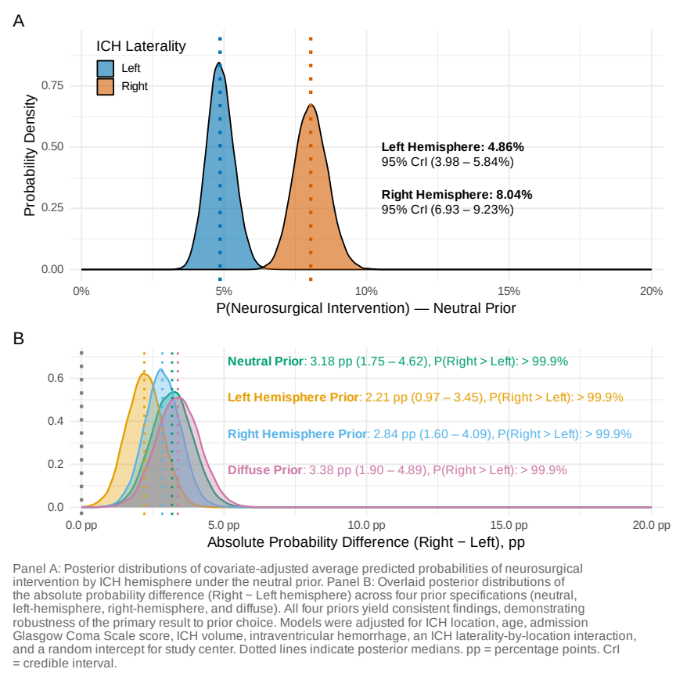
Figure 1: Prior Sensitivity Analysis for Neurosurgical Intervention

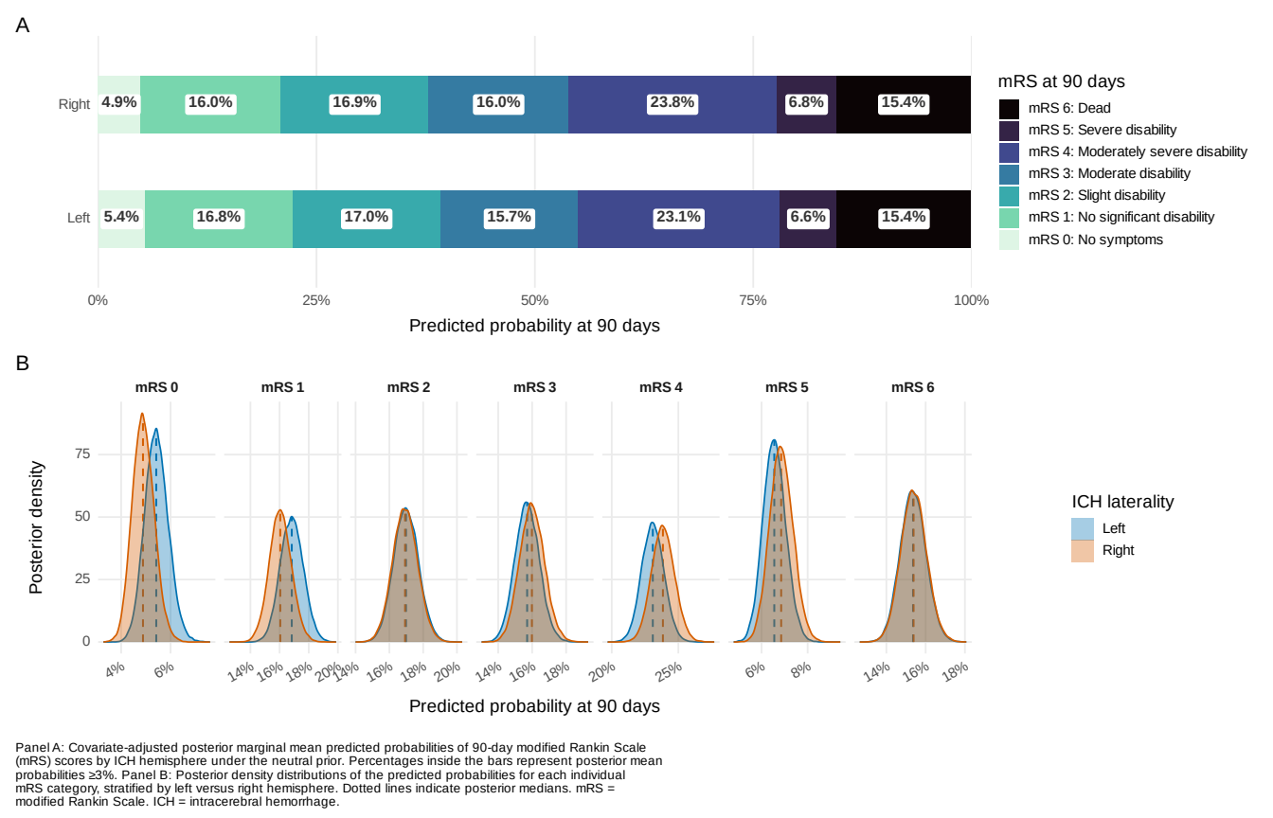
Figure 2: modified Rankin Score at 90 days Stratified by ICH Laterality

